Using tables given by Chaminda Sir in Last lecture

Contents

Summary 2

ER Diagram 3

Relational Model 4

Database Architecture 7

Final Set of Tables 9

Summary

ER Diagram

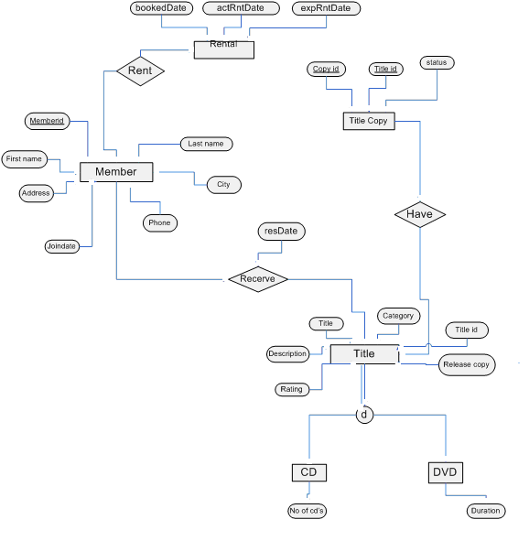

Relational Model
Relations

member (memberID ,lName ,fName,addr ,city ,place, jDate )

cd(titleID,title,[description],rating,category,relDate , No of cd’s)

dvd(titleID,title,[description],rating,category,relDate, Duration )

fileCopy ( copyID,titleID,ststus)

rentel(memberID,copyID, titleID, bookedDate ,actRntDate,expRntDate )

reservation(memberID,titleID, resDate)

1NF Normalization

member (memberID ,lName ,fName,addr ,city ,place, jDate )

cd(titleID,title,[description],rating,category,relDate , No of cd’s)

dvd(titleID,title,[description],rating,category,relDate, Duration )

fileCopy ( copyID,titleID,ststus)

rentel(memberID,copyID, titleID, bookedDate ,actRntDate,expRntDate )

reservation(memberID,titleID, resDate)

2NF Normalization

Above relations does not have partial dependencies. No attributes can be identified by the part of the primary key. So all above relations are in 2NF.

3NF Normalization

There are no transitive dependencies in any relation. So, above relations are in the 3NF.

Cording

Tables

DROP DATABASE CDReservation
CREATE DATABASE CDReservation
USE CDReservation
------------------------------------------------------------------------------------------------
CREATE TABLE member(
memberID INT PRIMARY KEY ,
lName VARCHAR(20)NOT NULL,
fName VARCHAR(25),
addr VARCHAR(100),
city VARCHAR(30),
place VARCHAR(15),
jDate datetime NOT NULL DEFAULT GETDATE())

INSERT INTO member(memberID ,lName,fName,addr,city,place) VALUES(1,'s','s','s','s','s')
drop table member
select * from member
------------------------------------------------------------------------------------------------
CREATE TABLE title(
titleID INT PRIMARY KEY,
title VARCHAR(60)NOT NULL,
[description] VARCHAR(400),
rating VARCHAR(4) CHECK (rating IN ('g', 'pg', 'r', 'no17', 'nr')),
category VARCHAR(20)CHECK (category IN ('Drama', 'Comody', 'Action', 'Child', 'Scifc','Documentry')),
relDate datetime)

INSERT INTO title VALUES(1,'aaa','dfsdfsd','nr','Drama','2009/12/01')
select * from title
------------------------------------------------------------------------------------------------
CREATE TABLE fileCopy (
copyID INT PRIMARY KEY,
titleID INT FOREIGN KEY(titleID) REFERENCES dbo.title(titleID)ON UPDATE CASCADE,
ststus VARCHAR(10) NOT NULL CHECK (ststus IN ('Available', 'Distroyed', 'Rented', 'Reserved')))

DROP TABLE fileCopy
INSERT INTO fileCopy VALUES(1,1,'Rented')
select * from fileCopy
------------------------------------------------------------------------------------------------

CREATE TABLE rentel(
bookedDate DATETIME DEFAULT GETDATE(),
memberID INT FOREIGN KEY REFERENCES dbo.member(memberID)ON UPDATE CASCADE,
copyID INT FOREIGN KEY REFERENCES dbo.fileCopy(copyID)ON UPDATE CASCADE,
actRntDate DATETIME,
expRntDate AS (actRntDate+2),
titleID INT FOREIGN KEY REFERENCES dbo.title(titleID)ON delete CASCADE)--Because of a conflict of cascade

DROP TABLE rentel
INSERT INTO rentel(memberID,copyID,actRntDate,titleID) VALUES (1,1,'2009/12/01',1)
SELECT * FROM rentel
------------------------------------------------------------------------------------------------
CREATE TABLE reservation(
resDate DATETIME PRIMARY KEY,
memberID INT FOREIGN KEY REFERENCES dbo.member(memberID)ON UPDATE CASCADE,
titleID INT FOREIGN KEY REFERENCES dbo.title(titleID)ON UPDATE CASCADE)

INSERT INTO reservation VALUES('2009/12/01',1,1)
SELECT * FROM reservation
drop table reservation

CREATE TABLE cd(
titleID INT PRIMARY KEY,
title VARCHAR(60)NOT NULL,
[description] VARCHAR(400),
rating VARCHAR(4) CHECK (rating IN ('g', 'pg', 'r', 'no17', 'nr')),
category VARCHAR(20)CHECK (category IN ('Drama', 'Comody', 'Action', 'Child', 'Scifc','Documentry')),
relDate datetime,
no_of_cds int)

CREATE TABLE dvd(
titleID INT PRIMARY KEY,
title VARCHAR(60)NOT NULL,
[description] VARCHAR(400),
rating VARCHAR(4) CHECK (rating IN ('g', 'pg', 'r', 'no17', 'nr')),
category VARCHAR(20)CHECK (category IN ('Drama', 'Comody', 'Action', 'Child', 'Scifc','Documentry')),
relDate datetime,
duration int)

PROCEDURES

----------------------------------------------Member Table-----------------------------------------------------

drop table member
select * from member

DROP PROCEDURE insert_member_SP

CREATE PROCEDURE insert_member_SP
@memberID INT ,
@lName VARCHAR(20),
@fName VARCHAR(25),
@addr VARCHAR(100),
@city VARCHAR(30),
@place VARCHAR(15)
AS
INSERT INTO member(memberID ,lName,fName,addr,city,place)
VALUES(@memberID,@lName,@fName,@addr,@city,@place)

EXEC insert_member_SP 01,'Perera','Kamal','55/b Colombo','Ja-ela','Town' -- JDate is Default in Table

----------------------------------------------Title Table-------------------------------------------------------------

CREATE PROCEDURE insert_title_SP
@titleID INT ,
@title VARCHAR(20),
@des VARCHAR(25),
@rating VARCHAR(100),
@category VARCHAR(30),
@relDate VARCHAR(15)
AS
INSERT INTO title VALUES(@titleID,@title,@des,@rating,@category,@relDate)

EXEC insert_title_SP 01,'Titenic','2 cds','g','Drama','1980-01-22'

----------------------------------------------fileCopy Table-----------------------------------------------------------

CREATE PROCEDURE insert_fileCopy_SP
@cid INT,
@tid INT,
@ststus VARCHAR(10)
AS
INSERT INTO fileCopy VALUES(@cid ,@tid,@ststus)

EXEC insert_fileCopy_SP 1,1,'Rented'

----------------------------------------------Rente Tablel-------------------------------------------------------------

CREATE PROCEDURE insert_rentel_SP
@memberID INT,
@copyID INT ,
@actRntDate DATETIME,
@titleID INT
AS
INSERT INTO rentel(memberID,copyID,actRntDate,titleID) VALUES (@memberID,@copyID,@actRntDate,@titleID)

EXEC insert_rentel_SP 1,1,'2009/12/01',1

----------------------------------------------Reservation Table--------------------------------------------------------

CREATE PROCEDURE insert_reservation_SP
@resDate DATETIME ,
@memberID INT ,
@titleID INT
AS
INSERT INTO reservation VALUES(@resDate,@memberID,@titleID)

EXEC insert_reservation_SP '2009/12/01',1,1

----------------------------------------------End-----------------------------------------------------------------------
VIEW

CREATE VIEW title_avail
AS
SELECT title,ststus
FROM title t JOIN fileCopy c
ON t.titleID=c.titleID
ORDER BY title

Database

DROP DATABASE CDReservation
USE CDReservation
GO
CREATE DATABASE CDReservation
ON
PRIMARY ( NAME = res1
FILENAME = 'c:\program files\microsoft sql server\mssql\data\res1.mdf’,
SIZE = 100MB,
MAXSIZE = 200,
FILEGROWTH = 20),
( NAME = res 2,
FILENAME = 'c:\program files\microsoft sql server\mssql\data\ res 2.ndf',
SIZE = 100MB,
MAXSIZE = 200,
FILEGROWTH = 20),
LOG ON
( NAME = resl1,
FILENAME = 'c:\program files\microsoft sql server\mssql\data\ resl1.ldf',
SIZE = 100MB,
MAXSIZE = 200,
FILEGROWTH = 20)

Security

Query for System administrator:

CREATE LOGIN AAAA WITH PASSWORD = '8fd'
USE CDReservation
CREATE USER Abc FOR LOGIN AAAA

EXEC sp_addsrvrolemember Abc,SYSADMIN

Query for db_owner
CREATE LOGIN AAAA WITH PASSWORD = '8fd'
USE CDReservation
CREATE USER Abc FOR LOGIN AAAA

EXEC sp_addrolemember 'db_owner', 'Abc'

Query for aew client
CREATE LOGIN AAAA WITH PASSWORD = '8fd'
USE CDReservation
CREATE USER Abc FOR LOGIN AAAA

CREATE ROLE client
GRANT INSERT,UPDATE ON client.reservation

sp_addrolemember 'AccMembers', 'Abc'

